2022 Models Collaborative Solution

[Her bert](https://www.youtube.com/shorts/aymLIdTNAc8)

Lmao

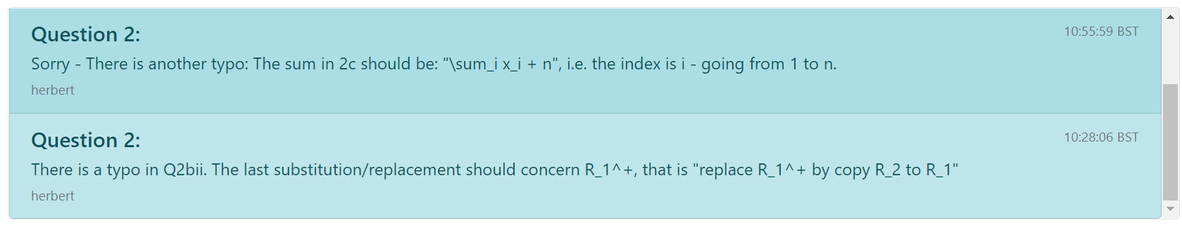

Q1

**a.i.** 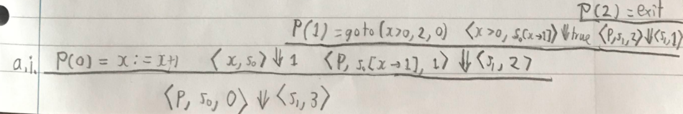

**a.ii.** k is the number of instructions executed

**a.iii.** goto(i) is an immediate jump to command i and goto(B, i, j) is a conditional jump; when B is true it jumps to command I, otherwise it jumps to command j.

**a.iv.** goto(i) = goto(true, i, 0)

**b.**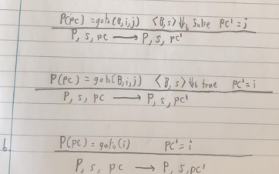

**c.** 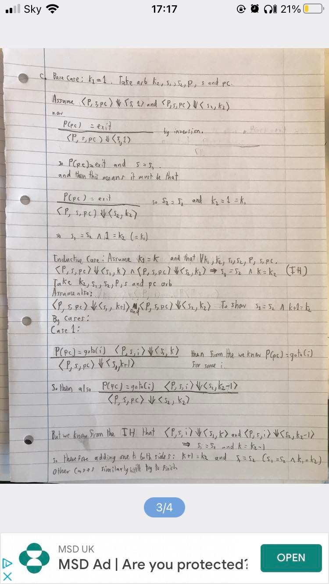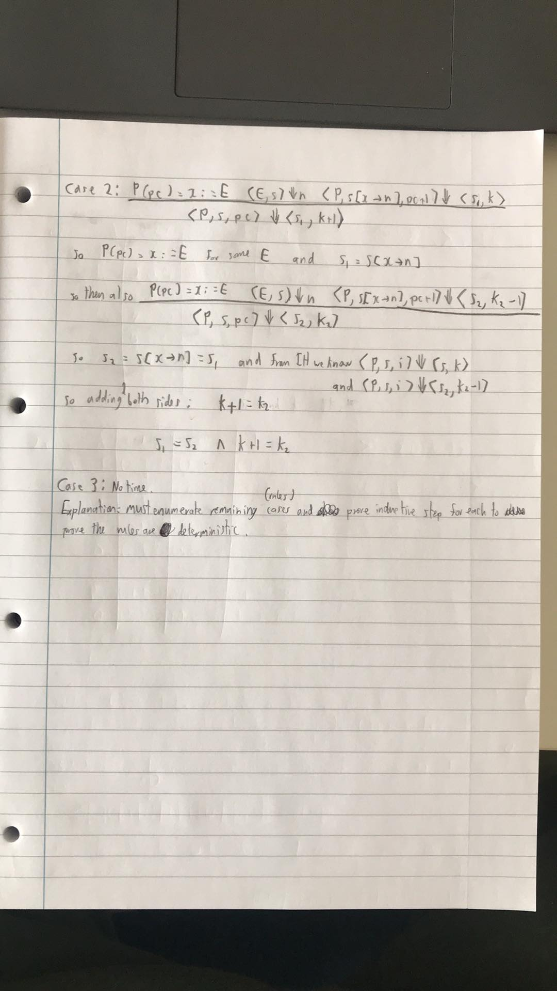

1c Alternative (2023 format. the question will give you names of the rules)

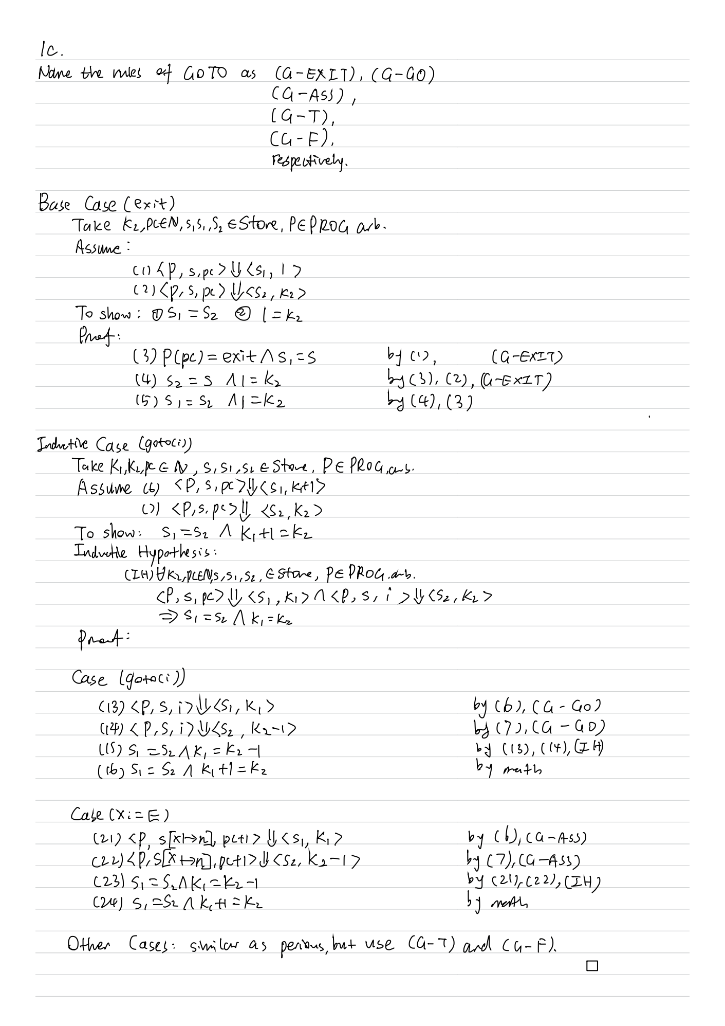

Q2 (The day of this exam is 6th May 2022)

**a, bi.**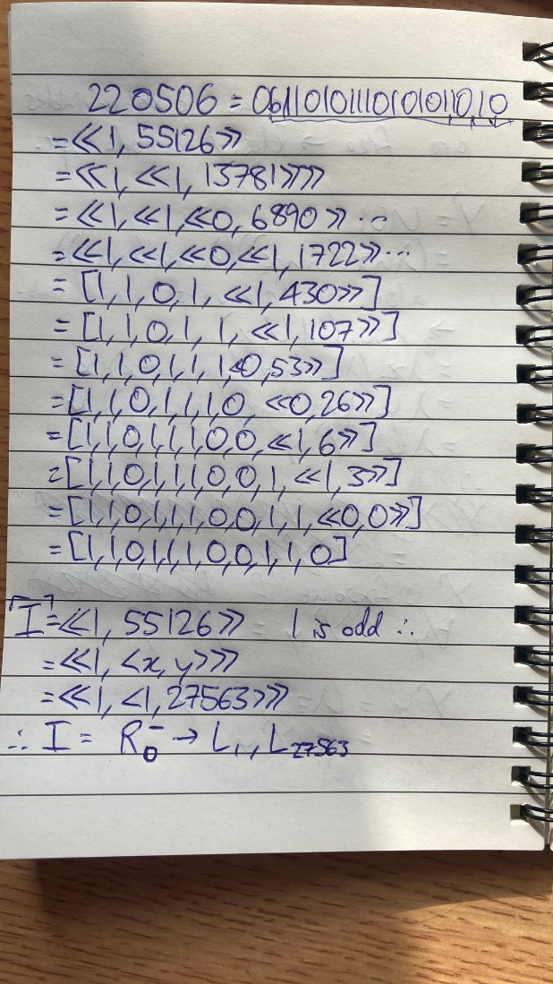

Useful link for checking answers to 2a: <https://flutter-rm.herokuapp.com/>

b.ii. typo again.

Disclaimer: treat this with a pinch of salt as I did this under timed conditions and haven’t checked this at all (this disclaimer can be removed if people are happy the solution is correct).

To the left of each configuration is the label number corresponding to the solution given to 2bi in the above image.

Update: one mistake I think I made was that the gadget that pushes X to L zeroes out X in the process – I didn’t take this into account.

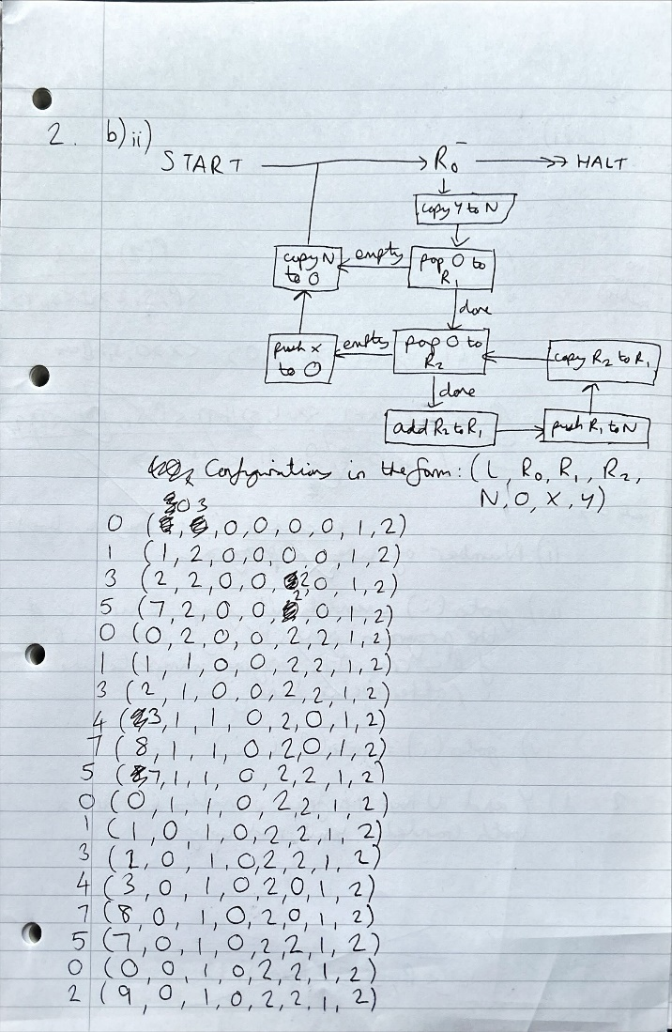

b.iii.

Examiner report: “Important was to realise that in effect the RM was intended to deal with lists of numbers rather than single numbers as indicated by the use of pop and push gadgets. The RM - applying the correct substitutions - would essentially compute a list of binomial coefficients (i.e. Pascal's triangle) by summing two elements of the previous lists.”

**c.** 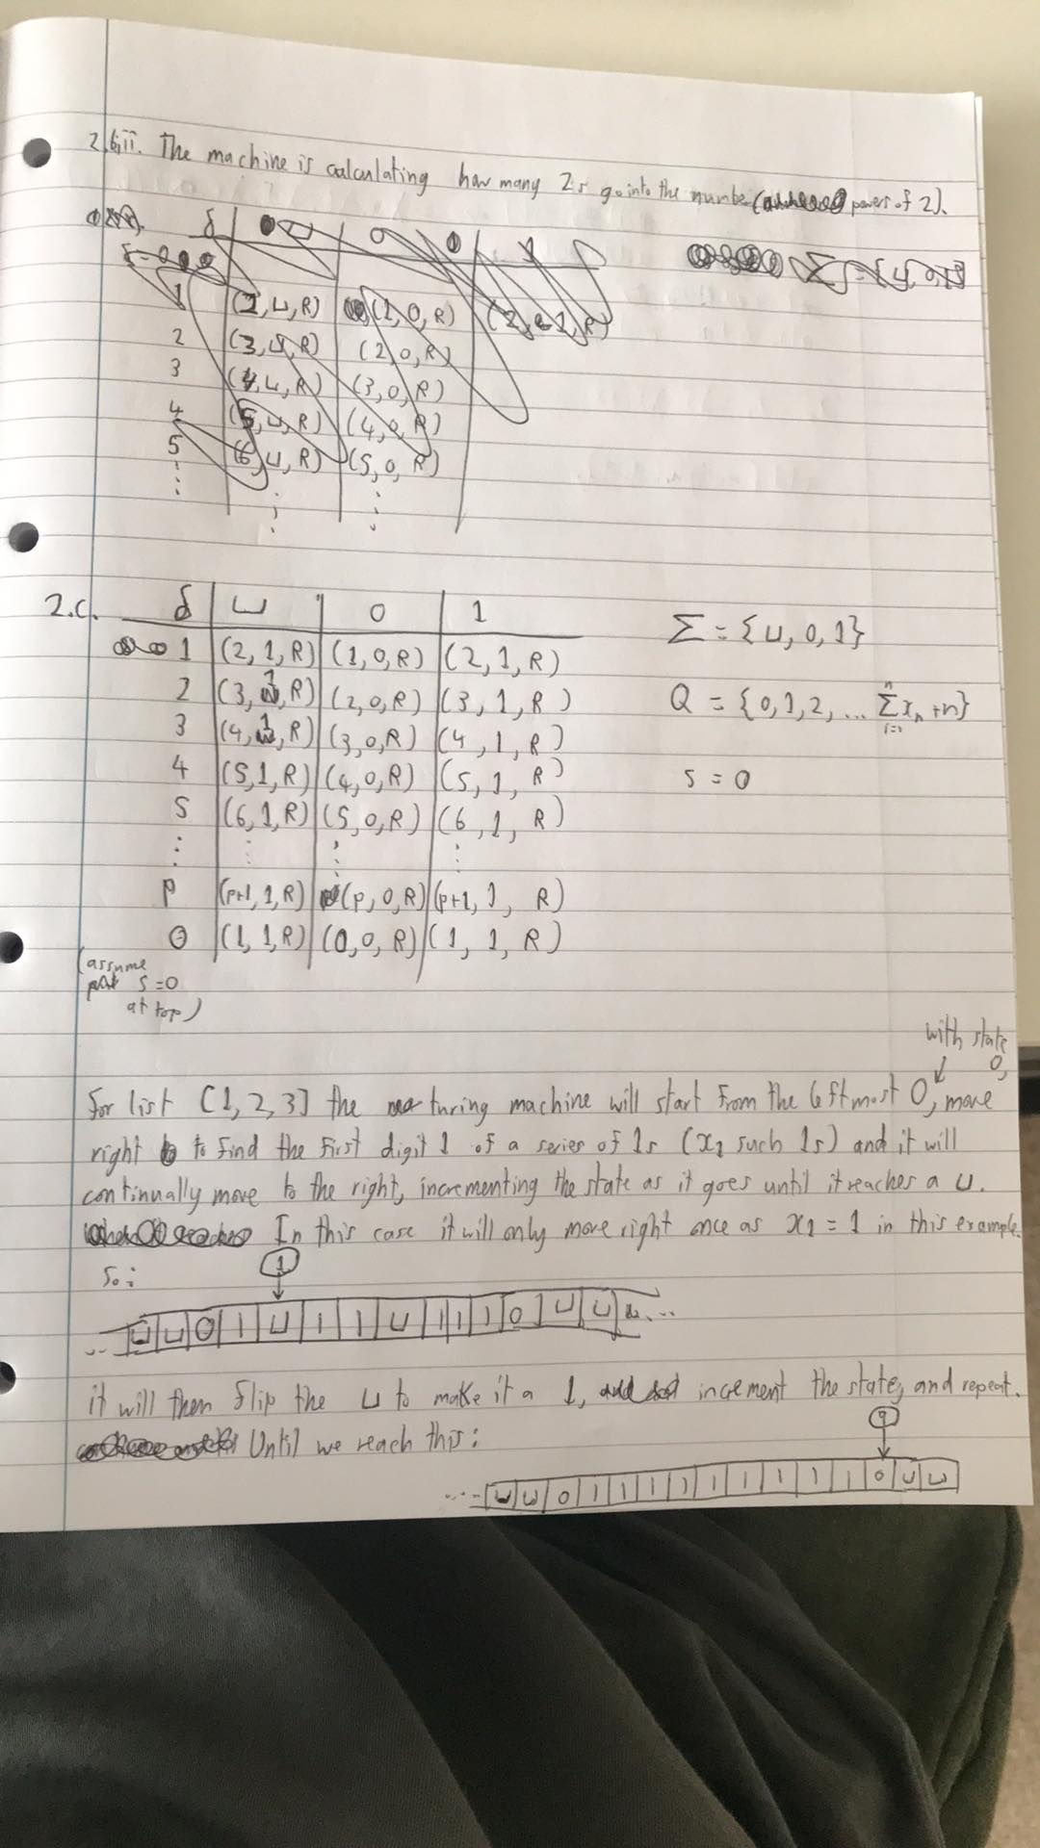

d.

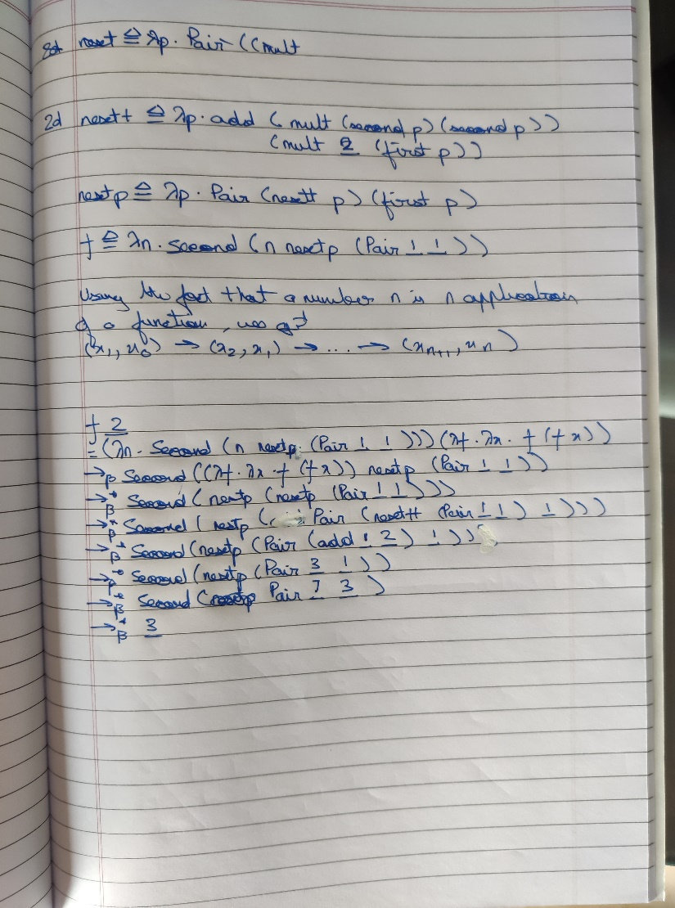

Another solution:  
f = Y(\f n . (ifz n) 1 ((ifz (pred n)) 1 (plus (mul 2 (f (pred n))) (mul (f (pred (pred n))) (f (pred (pred n)))))))

essentially

if n = 0 then 1

else

If pred n = 0 then 1

else (f (pred (pred n)) * (f (pred (pred n)) + 2 * f (pred n)

*Use dynamic programming to define f', a more efficient version of f, and*  
*state its complexity.*  
*Hint: You may use the tabulate :: Ix i ⇒ (i, i) → (i → a) → Array i a function*  
*from lectures.*